**Insight 1- Which Airlines or Airports Have the Worst Delays?**

<https://public.tableau.com/profile/abdullah.aldossari#!/vizhome/Flight_Data_Analysis-UdacityFinalProject/FlightCancellationDashboard?publish=yes>

**Summary**

From this Dashboard we can see that Southwest Airlines and the state of Texas has the highest number for flight delays in 2015. Southwest Airlines had the poorest performance when it comes to delays and it is the worst airlines handling it. With almost 172,000 delays in total in the year 2015.

**Design**

I chose this dashboard to see the horizontal bars and a map of the US to give me and the audience an idea of the locations for the airports and the graph next to it where I can compare airlines. There is also a filter to choose in which state the airline is located to help the audience understand about the Airline hub. For example, if we choose Southwest Airlines we can see it is in the state of Texas which has the highest delays.

**Insight 2- What Causes Delays?**

<https://public.tableau.com/profile/abdullah.aldossari#!/vizhome/Flight_Data_Analysis-UdacityFinalProject/FlightCancellationDashboard?publish=yes>

**Summary**

There are seven reasons to cause delays which are.

1. Departure Delay
2. Arrival Delay
3. Late Aircraft Delay
4. Airline Delay
5. Air System Delay
6. Security Delay
7. Weather Delay

**Design**

I chose this bar chart design to compare different airlines delays. Where you can select the airline code from the filter and see the delays that happened and what are they.

**Insight 3** – Which airlines has the highest cancelled flights? and in which airport and day of the week?

<https://public.tableau.com/profile/abdullah.aldossari#!/vizhome/Flight_Data_Analysis-UdacityFinalProject/FlightCancellationDashboard?publish=yes>

**Summary-**

American Eagle airlines has the most cancelled flights with 174 cancelled flights that happened in Chicago O’Hare International Airport. On the other hand, we can see that US Airways has only 2 cancelled flights in Miami International Airport. Moreover, when you look at the pie chart you can see the day of the week the cancellation happened, for example if you select Sunday it will show you that weather delay is the reason the flights were cancelled with 603 in total in all of the airports.

**Design**

I chose this packed bubble to compare the different airports and the most cancellations that occurred in 2015. Also you can highlight the airlines to see where the cancellation occurred, where in the pie chart you can see in which day of the week has the cancellation occurred.

Insight 3 – Which Airport has the highest cancellation flights rate

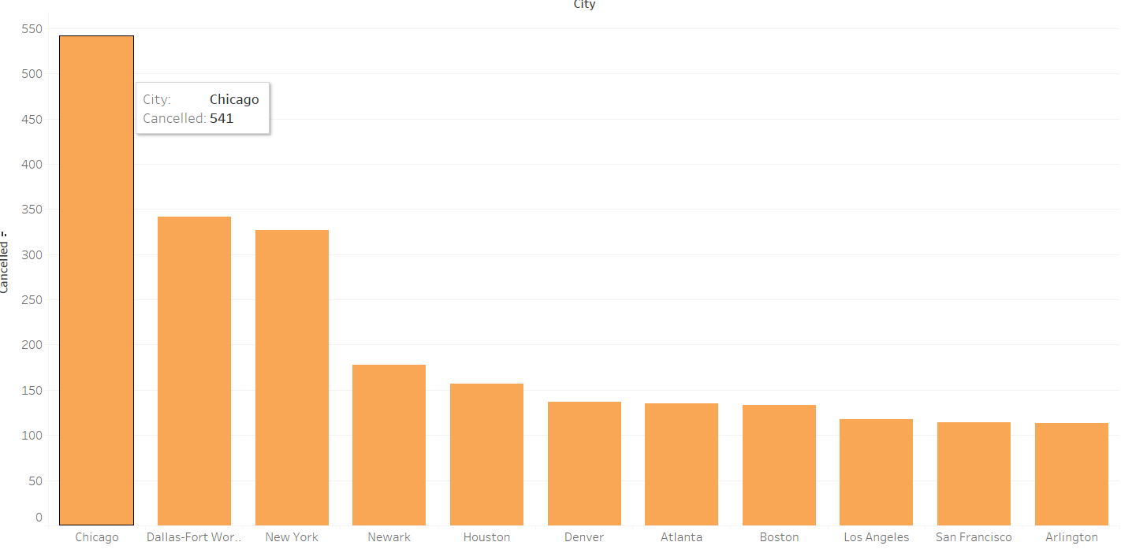

I chose this design because I want to visualize the map and to see a bar chart with the highest cancellation flights per state. This graph shows that which airport has the highest flights cancellation. According to the graph Chicago O’hare Airport has the highest flights cancellation with 541cancelled flights and Dallas Airport comes second, and New York Airport comes third. However, we can also see there are states with lease flights cancellation such as Delaware with 0 flight cancellation in 2015. In the graph there is also a filter for which days of the week cancellation occurred.